Instructions for compiling ISOmodel using Visual Studio 2022 / VS 2022 community edition

As of 15-Dec-2025 Boost dependence has been removed and Google Test is downloaded automagically along with yaml stuff as part of the compile process. This makes install and compilation much easier for both Windows and Linux based development.

If you plan to work from the publicly available, open source, ISOmodel git repository and keep your changes/additions open source, the terms of use allow use of VS 2022 community edition even if you are a commercial business or enterprise. If you are a commercial company and plan on keeping those changes within your company or releasing in closed source software, you cannot use VS 2022 community edition and must have a licensed version VS 2022 Pro.

In the setup process it’s best to install CMake first so that the Visual Studio environment can find CMake during its own install.

Install CMake >=3.20
https://github.com/Kitware/CMake/releases/download/v4.0.1/cmake-4.0.1-windows-x86_64.msi
https://cmake.org/download/
Choose the latest version of CMAKE for windows X64 installer

Install with the option “Add CMake to the PATH environment variable” checked.
This will prompt for admin login

Download VS 2022/ VS 2022 Community Edition and begin installing
Select Desktop development with C++ and use default settings. You might want to uncheck GitHub Copilot if you don’t want more Copilot stuff. Here is what my install looks like with GitHub Copilot unchecked.

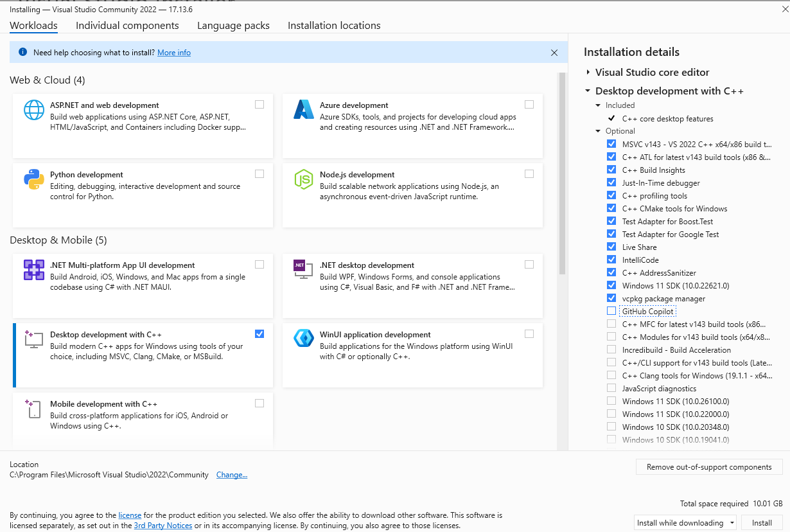

Creating Visual Studio Project Files

First we need to create the .sln files

Open a command prompt that has cmake in the path.

Go to isomodel directory root (e.g. c:\git\isomodel\isomodel\) and make a bin directory for the binaries

cd C:\git\isomodel\isomodel
mkdir bin
cd bin

Now, if you are lucky, cmake will autodetect Visual Studio 22 and you can create the Visual Studio 2022 project files with the command line:

cmake ../src

If all goes well things will run, print some output, a couple warnings but then finally end with the following lines (times will differ on your machine)

-- Configuring done (73.1s)
-- Generating done (1.1s)
-- Build files have been written to: C:/Git/ISOmodel/IsoModel/bin

Here is the full output on my computer
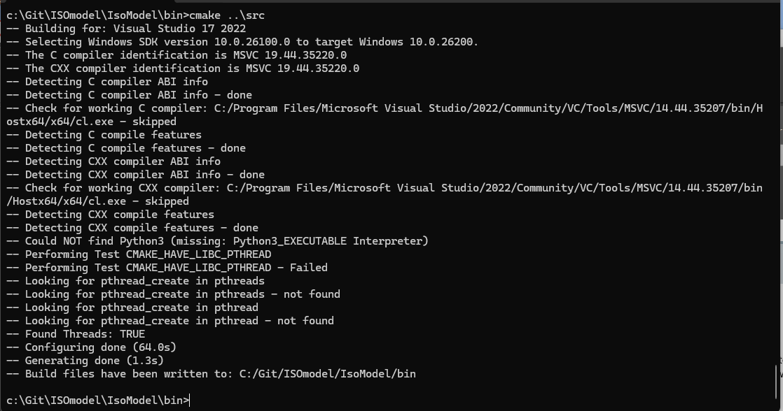

If cmake terminates in an error cmake might not finding the Visual Studio compiler properly.

If you don’t see something like the following line at the top, then the Visual Studio compiler was not found (exact #’s will change as VS 2022 has updates)
-- Building for: Visual Studio 17 2022
And then farther down
-- The C compiler identification is MSVC 19.44.35217.0
-- The CXX compiler identification is MSVC 19.44.35217.0

To try to fix this problem you can tell cmake explicitly the version by specifically adding info on the command line with cmake.

Try:

cmake ../src -G "Visual Studio 18 2026"

A completed cmake process will have created a CMakeFiles directory and a bunch of other visual studio project files in the bin directory including “isomodel_project.sln”. My directory looks like the following
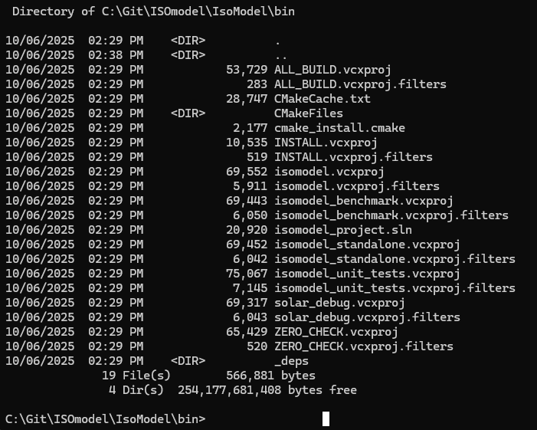

Compiling isomodel using Visual Studio IDE

Load isomodel_project.sln into Visual Studio and change build to Release, x64 and build the entire project

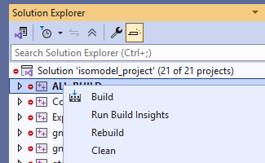

This will compile yaml-cpp, googletest, and the ISOmodel. You should get no warnings/errors when Visual Studio is compiling yaml-cpp and googletest, but will get many warnings when compiling the ISOmodel itself. Hopefully the compiling will occur without error and youll eventually get output like this:

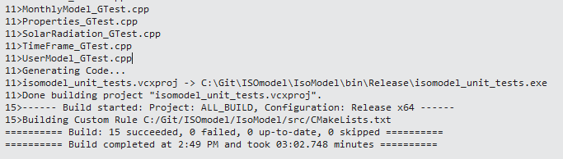

Testing the Build.

You can most easily test the build by running the isomodel unit tests.
Go into the Release directory and run isomodel_unit_tests

cd Release
isomodel_unit_tests.exe

The output should look something like this:

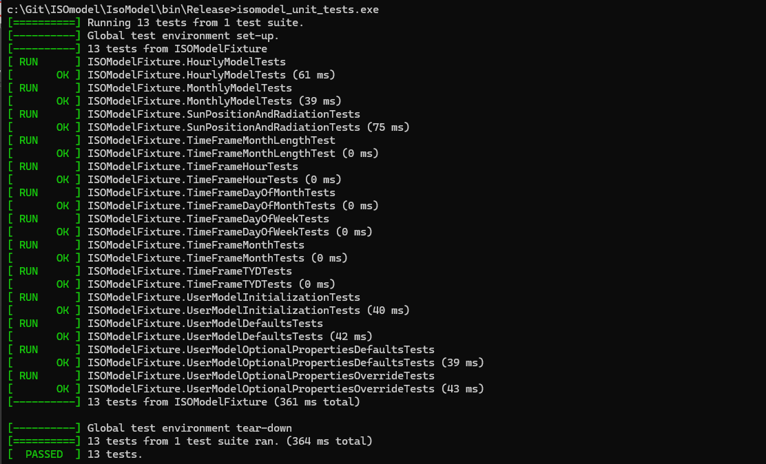

You could also run the isomodel_benchmark that is in the release directory:

cd Release
isomodel_benchmark.exe .

You should get something like this:
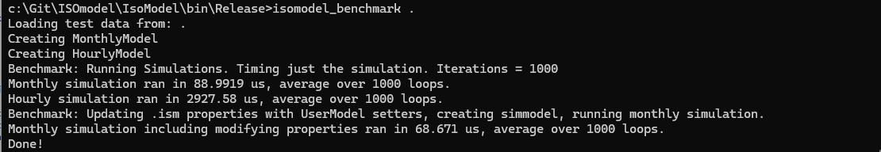

Finally, you can also run the isomodel standalone
cd Release
isomodel_standalone.exe -h test_bldg.yaml

The output should look something like this:

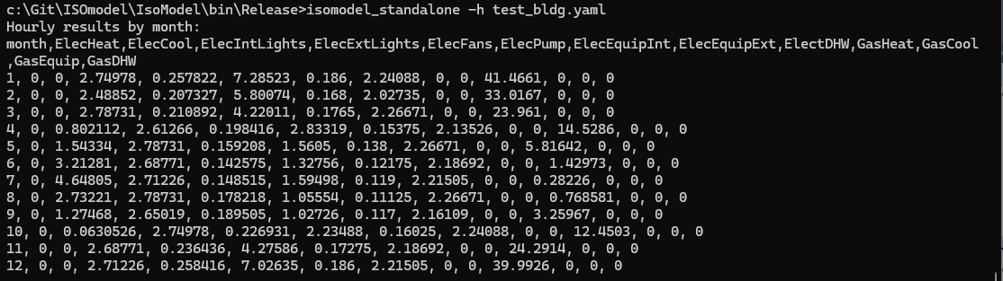

You can run in other modes using -m, or -H. -m is monthly mode, -H is hourly mode with all 8760 hours output

Congratulations: You have compiled the ISOmodel!

